Supplementary Information

A model-based assessment of anthropogenic disturbance on lotic macroinvertebrate assemblages

Darin A. Kopp1*, John L. Stoddard1, Philip R. Kaufmann1,2, Alan T. Herlihy2, Ryan A. Hill1, Meredith M. Brehob3, Robert D Sabo4

1US EPA, Office of Research and Development, Corvallis, Oregon, USA

2Department of Fisheries, Wildlife, & Conservation Sciences, Oregon State University,

Corvallis, Oregon, USA

3Oak Ridge Institute for Science and Education Participant c/o US EPA, ORD, Washington, D.C., USA

4US EPA, Office of Research and Development, Center for Public Health and Environmental Assessment, Washington, DC, USA

*Correspondence: kopp.darin@epa.gov

Keywords: Joint Species Distribution Modeling, Richness, National Rivers and Streams Assessment, Benthic Macroinvertebrate, Reference Sites, National Aquatic Resource Surveys.

Table S1: Geoclimatic and anthropogenic variables used in random forest models. Variables were selected based on their hypothesized relationship with total nitrogen, total phosphorus, chloride, sulfate and substrate diameter. StreamCat data is publicly accessible at <https://www.epa.gov/national-aquatic-resource-surveys/streamcat-dataset> (Hill et al. 2016) and National Atmospheric Deposition Program Data is publicly accessible at <https://nadp.slh.wisc.edu/maps-data/ntn-gradient-maps/>

|  |  |  |
| --- | --- | --- |
| Variable | Description | Source |
| BFIWs | The component of streamflow that can be attributed to ground-water discharge | StreamCat, Hill et al. 2016 |
| ClayWs | Mean % clay content of soils in watershed | StreamCat |
| ElevWs | Mean elevation of watershed (m) | StreamCat |
| KffactWs | Mean of STATSGO Kffactor | StreamCat |
| DepClWs | Mean atmospheric chloride deposition 2018 | National Atmospheric Deposition Program |
| DepPWs | Atmospheric phosphorous deposition 2013 | Sabo et al 2023 |
| NWs | Rock derived nitrogen in watershed | StreamCat |
| P2O5Ws | Mean % of lithological phosphorous oxide (P2O5) content in surface or near surface geology | StreamCat |
| PctAlluvCoastWs | % of watershed area classified with lithology type as alluvium and fine-textured coastal zone sediment | StreamCat |
| PctHbWetWs | % of watershed area classified as herbaceous wetland land cover | StreamCat |
| PermWs | Mean permeability (cm/hour) of soils (STATSGO) within watershed | StreamCat |
| RunoffWs | Mean runoff (mm) within watershed | StreamCat |
| SandWs | Mean % sand content of soils (STATSGO) within watershed | StreamCat |
| StreamPower | An index reflecting the amount of energy the water exerts on the sides and bottom of a stream | (((TPRCP - ET)/1000 )*(0.032*WSArea)^0.5) * slope |
| SWs | Mean % of lithological sulfur (S) content in surface or near surface geology within watershed | StreamCat |
| WsAreaSqKm | Area of watershed (square km) | StreamCat |
| CoalMineDensWs | Density of coal mines sites within watershed (mines/square km) | StreamCat |
| DepNWs | Mean atmospheric nitrogen deposition in watershed 2018 | National Atmospheric Deposition Program |
| DepSWs | Mean atmospheric sulfur deposition in watershed 2018 | National Atmospheric Deposition Program |
| MineDensWs | Density of coal mines sites within watershed (mines/square km) | StreamCat |
| N_inputs | Sum of anthropogenic nitrogen inputs: N_Fert_FarmWs, N_Fert_UrbanWs, N_Human_WasteWs, N_Livestock_WasteWs | Sabo et al. 2023 |
| P_inputs | Sum of anthropogenic phosphorus inputs: P_f_fertilizerWs, P_human_wasteWs, P_livestock_WasteWs, P_nf_fertilizerWs | Sabo et al. 2023 |
| PctCropWs | % of watershed area classified as crop land use | StreamCat |
| PctCropWsRp100 | % of watershed riparian area classified as crop land use | StreamCat |
| PctNatWs | % of watershed with natural vegetation cover | StreamCat |
| TPRCP | Ln(Mean total annual precipitation, 2018 or 2019) | PRISM |
| RdDensWs | Density of roads (2010 Census Tiger Lines) within watershed (km/square km) | StreamCat |
| MSAT | Mean summer (July/August) air temperature (C°), 2018 or 2019 | PRISM |
| W1_HAG | Agricultural disturbance adjacent to a stream | NRSA Field Data |
| NABD_NrmStorWs | Volume all reservoirs per unit area of watershed (cubic meters/square km) | StreamCat |

Table S2: Variable importance rankings for random forest models and values used to estimate physiochemical conditions in the absence of anthropogenic disturbance. The 5 most important variables for each model are bold.

|  |  |  |  |  |  |  |  |
| --- | --- | --- | --- | --- | --- | --- | --- |
| Predictor Variable | NTL | PTL | CL | SO4 | SUBD | Range of Predictor  Present-day | Value Without Disturbance |
| **Geoclimatic** |  | | | | | | |
| BFIWs | 6 | 13 | 7 | 8 | - | 2.6 - 88 | -- |
| ClayWs | - | 10 | 8 | 12 | - | 2.35 - 60.6 | -- |
| ElevWs | 10 | **4** | 6 | 9 | - | 2.02 - 3587.98 | -- |
| KffactWs | 13 | 11 | 15 | 14 | 9 | 0.01 - 0.48 | -- |
| DepClWs | - | - | 9 | - | - | 0.13-43.16 | -- |
| DepPWs | - | **5** | - | - | - | 2.03-15.9 | -- |
| NWs | 9 | - | 11 | **4** | - | 0-1.59 | -- |
| P2O5Ws | 16 | 9 | 18 | 15 | - | 0.02-2.42 | -- |
| PctAlluvCoastWs | - | - | - | - | 6 | 0-100 | -- |
| PctHbWetWs | 7 | 8 | 10 | 16 | - | 0-40.35 | -- |
| PermWs | 14 | 14 | 17 | 13 | - | 0.32-45.23 | -- |
| RunoffWs | **2** | **2** | **4** | **1** | **2** | 0.05-3731.74 | -- |
| SandWs | - | - | - | - | 8 | 2.8-92.04 | -- |
| StreamPower | - | - | - | - | **1** | 0-0.44 | -- |
| SWs | 12 | 15 | **5** | **3** | - | 0.01-23.66 | -- |
| WsAreaSqKm | 15 | 12 | 14 | 11 | **5** | 0.21-2,874,021.46 | -- |
| **Anthropogenic** |  | | | | | | |
| CoalMineDensWs | - | - | 19 | 7 | 13 | 0 - 5.74 | 0 |
| DepNWs | **5** | - | - | - | - | 1.12 - 26.15 | 5 kgN/ha/yr* |
| DepSWs | - | - | 12 | 10 | - | 0.22 - 5.88 | 1.65 kgS/ha/yr* |
| MineDensWs | - | - | 16 | 18 | 12 | 0 - 0.13 | 0 |
| N_inputs | **3** | - | - | - | - | 0 - 6.22 | 0 |
| P_inputs | - | 7 | - | - | - | 0 - 2.19 | 0 |
| PctCropWs | **1** | **1** | **3** | **2** | - | 0 - 96.7 | 0 |
| PctCropWsRp100 | - | - | - | - | **4** | 0 - 95.52 | 0 |
| PctNatWs | - | - | - | - | **3** | 0 - 100 | 100 |
| TPRCP | 11 | 16 | 13 | 17 | - | 4.61 - 8.28 | Average 1900-1950 |
| RdDensWs | **4** | 6 | **2** | 5 | 10 | 0 - 15.15 | 0 |
| MSAT | 8 | **3** | **1** | 6 | - | 11.71 - 36.11 | Average 1900-1950 |
| W1_HAG | - | - | - | - | 7 | 0 - 2.18 | 0 |
| NABD_NrmStorWs | - | - | - | - | 11 | 0 – 1,886,390.68 | 0 |

* Estimates for atmospheric nitrogen and sulfur deposition were obtained from Clark et al. 2018. Although they used 0.4 kgN/ha and 0.1kgS/ha no sites had deposition values below this level. Instead, we selected the higher values of 3-5KgN/ha as reasonable estimates for background deposition values before 1900. For S deposition, other efforts have estimated pre-industrial S deposition at 0.32–2.98 kgS/ha (Granat et al. 1976, Fakhraei et al. 2016) and we used the used middle number of this interval as a reasonable estimate for background.

Figure S1: Sites flagged for potential extrapolation after removing anthropogenic effects from the random forest models. NTL = total nitrogen; PTL is total phosphorus; CL is chloride; SO4 is sulfate; LSUB = substrate diameter, Any = sites that were flagged for extrapolation for any model and removed from the analysis. The number of sites removed is as follows (CPL = 40 (18%); NAP = 2 (1%); NPL = 1 (1%); SAP = 1 (<1%); SPL = 6 (3%); TPL = 13 (6%); UMW=3 (1%); WMT = 2(1%) and XER = 5 (3%))

Table S3. Variance inflation factors (VIF) for predictor variables used for joint species distribution models. In general, VIF >5 indicates a strong correlation between variables while values VIF < 3 indicate low correlation between values. Bold font = VIF >3; NTL = Total Nitrogen, PTL = Total Phosphorus, CL = Chloride, SO4 = Sulfate, SUBD = Substrate Diameter, RPDI = Riparian Disturbance index, MSAT = Mean Summer Air Temperature, PRCP = Total Annual Precipitation.

|  |  |  |  |  |  |  |  |  |
| --- | --- | --- | --- | --- | --- | --- | --- | --- |
|  | NTL (ug/L) | PTL  (ug/L) | CL  (mg/L) | SO4 (mg/L) | SUB  (mm) | RPDI | MSAT  (DegC) | TPRCP  (mm) |
| CPL | 2.17 | 1.87 | 2.83 | 2.5 | 1.09 | 1.3 | 1.25 | 1.14 |
| NAP | **3.08** | 2.6 | **3.34** | 1.67 | 1.1 | 1.28 | 2.47 | 1.07 |
| NPL | 2.8 | 2.2 | 2.82 | 2.94 | 1.39 | 1.11 | 1.84 | 1.5 |
| SAP | 2.42 | 1.85 | 2.6 | 1.49 | 1.13 | 1.3 | 1.21 | 1.04 |
| SPL | 2.49 | 2.57 | 2.65 | 2.12 | 1.22 | 1.17 | 1.63 | 1.28 |
| TPL | 1.57 | 1.35 | 1.22 | 1.45 | 1.11 | 1.11 | 1.52 | 1.5 |
| UMW | 2.37 | 1.92 | **3.13** | 2.57 | 1.09 | 1.46 | **4.25** | 1.15 |
| WMT | 1.79 | 1.6 | 2.22 | 1.86 | 1.25 | 1.34 | 1.47 | 1.29 |
| XER | 2.28 | 1.77 | **4.1** | **3.23** | 1.29 | 1.19 | 1.69 | 1.44 |

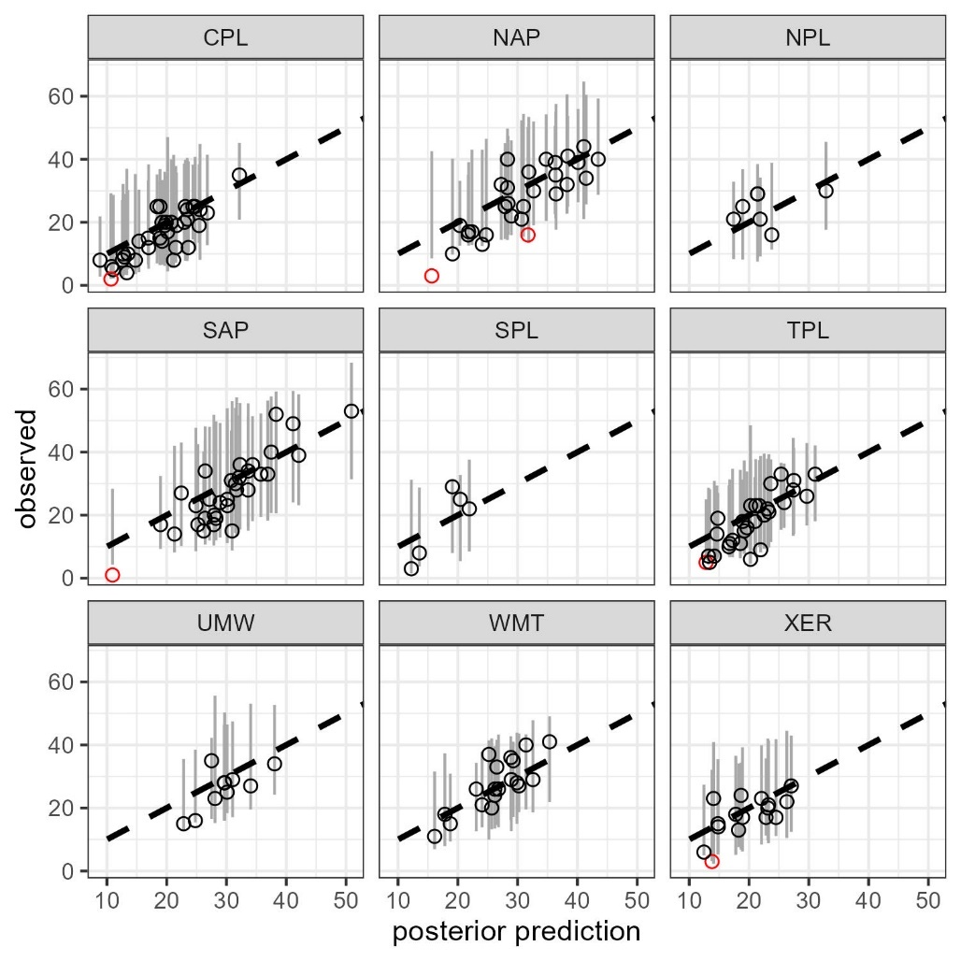

Figure S2. Validation of JSDM using revisit surveys. As part of NRSA, a subsample of sites are resurveyed. We used these data to provide additional validation of the predictive capabilities of JSDMs. We found that when using condition prediction (Ovaskainen and Abrego 2020), the posterior distribution of all JSDM typically contained all observed genus richness values. This result suggests that the observed genus richness could be a random sample drawn from our modeled posterior distribution and suggests that our models can accurately predict the occurrence of taxa during the initial visit. Black points indicate that the observed genus richness is within the predicted posterior distribution; Red points indicate that the observed genus richness is outside the predicted posterior distribution; Dotted line is 1:1 between observed and posterior mean richness and grey lines represent the distribution of 3,000 samples from the posterior distribution.

Table S4. Regional means of present-day (PD) and hindcasted (HC) values for each environmental gradient. Parentheses are 10th and 90th quantiles of observed hindcasted values. NTL = Total Nitrogen, PTL = Total Phosphorus, CL = Chloride, SO4 = Sulfate, SUBD = Substrate Diameter, RPDI = Riparian Disturbance index, MSAT = Mean Summer Air Temperature, PRCP = Total Annual Precipitation.

|  |  |  |  |  |  |  |  |  |  |  |  |  |  |  |  |  |
| --- | --- | --- | --- | --- | --- | --- | --- | --- | --- | --- | --- | --- | --- | --- | --- | --- |
|  | NTL (ug/L) | | PTL (ug/L) | | CL (mg/L) | | SO4 (mg/L) | | SUB (mm) | | RPDI | | MSAT (DegC) | | TPRCP (mm) | |
|  | PD | HC | PD | HC | PD | HC | PD | HC | PD | HC | PD | HC | PD | HC | PD | HC |
| CPL | 702.5 (299.2-2027.2) | 380 (315.4-566.4) | 77.82 (23.07-234.27) | 48.67 (25.67-77.47) | 8.7 (2.89-68.94) | 3.7 (2.92-7.65) | 6.3 (1.08-34.55) | 3.29 (1.82-11.02) | 0.35 (0.01-2.73) | 3.32 (0.7-14.32) | 0.44 (0.03-1.58) | 0.33 (0.03-0.33) | 27.49 (25.63-28.54) | 27.02 (24.69-27.84) | 1623.25 (1178.37-1990.68) | 1219.49 (1015.53-1664.18) |
| NAP | 422 (187-1301) | 286 (188-327) | 23.62 (7.25-71.81) | 17.76 (10.04-27.89) | 16.58 (0.46-72.61) | 1.92 (0.3-3.82) | 5.57 (1.71-15.63) | 2.9 (1.74-6.07) | 12.09 (0.09-122.43) | 14.36 (3.4-47.45) | 0.65 (0-2.02) | 0.33 (0-0.33) | 21.49 (18.99-23.67) | 20.41 (18.31-21.75) | 1299.05 (1106.82-1629.65) | 1089.44 (949.5-1234.19) |
| NPL | 881.5 (265.9-2193.5) | 462.75 (216-694) | 85.89 (18.01-366.21) | 67.33 (38.47-85.9) | 12.09 (2.34-50.02) | 10.16 (1.45-19.62) | 486.24 (18.73-1340.1) | 172.31 (9.75-517.88) | 0.51 (0.01-18.45) | 3.1 (1.19-29.75) | 1.27 (0.38-2.08) | 0.33 (0.33-0.33) | 20.52 (18.34-22.49) | 21.19 (19.1-23.77) | 437.42 (320.65-632.12) | 361.68 (282.17-428.71) |
| SAP | 556 (173-1876) | 284 (158-350) | 29.26 (9.83-128.25) | 24.3 (16.41-45.85) | 5.82 (1.34-47.53) | 2.7 (1.08-3.82) | 7.47 (1.55-80.36) | 3.88 (1.88-8.95) | 16.13 (0.35-206.69) | 14.32 (6.1-57.76) | 0.77 (0.05-2.29) | 0.33 (0.05-0.33) | 24.76 (22.09-26.68) | 24.05 (21.37-26.37) | 1476.55 (1108.36-1809.43) | 1110.8 (920.87-1283.9) |
| SPL | 1165 (438.5-2961) | 405.25 (301.75-627) | 143.62 (26.05-774.69) | 56.88 (37.68-76.58) | 29.21 (4.51-358.38) | 10.47 (4.29-29.42) | 86.1 (7.94-898.01) | 45.6 (8.5-334.85) | 0.35 (0.02-19.61) | 3.18 (0.92-12.68) | 1.02 (0.21-2.29) | 0.33 (0.21-0.33) | 25.84 (21.9-29.66) | 26.17 (22.03-28.92) | 616.17 (393.76-1051.75) | 534.19 (312.86-977.73) |
| TPL | 1868 (647.6-9147.8) | 418 (330.6-578) | 165.08 (54.39-444.97) | 50.96 (40.55-63) | 18.29 (7.1-62.09) | 5.7 (3.7-10.38) | 32.99 (11.93-256.93) | 13.48 (5.28-105.55) | 0.35 (0.01-16.28) | 7.79 (2.51-18.96) | 0.83 (0.13-2.29) | 0.33 (0.13-0.33) | 23.36 (21.05-25.28) | 23.63 (21.3-25.38) | 1004.99 (678.76-1395.29) | 775.15 (537.81-922.38) |
| UMW | 1188 (352.2-5320) | 371 (289.6-511.49) | 57.4 (16.93-166.88) | 36.03 (17.9-53.25) | 9.98 (0.76-29.9) | 2.72 (0.3-5.21) | 9.28 (1.12-40.68) | 3.65 (1.34-8.36) | 0.35 (0.01-12.6) | 6.1 (2.19-27.43) | 0.62 (0-2.1) | 0.33 (0-0.33) | 20.84 (18.13-22.56) | 20.98 (18.42-22.38) | 961.61 (801.29-1395.23) | 799.34 (623.5-877.62) |
| WMT | 133 (50-385.6) | 133 (66-235.1) | 22.12 (6.97-82.29) | 21.14 (9.3-53.81) | 0.92 (0.12-9.14) | 0.52 (0.16-3.13) | 2.97 (0.47-24.57) | 3.2 (0.86-15.04) | 38.14 (0.97-192.14) | 38.17 (6.1-99.8) | 0.48 (0-1.73) | 0.33 (0-0.33) | 18.08 (13.97-22.33) | 16.96 (12.57-21.33) | 648.86 (349.11-1670.25) | 688.27 (386.2-1778.26) |
| XER | 333 (107.2-1245.6) | 253 (133.8-418) | 53.87 (14.3-240.71) | 42.76 (15.83-84.65) | 5.23 (0.79-132.36) | 3.17 (0.68-20.77) | 25.08 (1.54-324.3) | 20.85 (1.93-112.43) | 2.18 (0.02-66.09) | 10.78 (2.1-44.24) | 1.14 (0.11-2.54) | 0.33 (0.11-0.33) | 22.76 (18.81-29.64) | 21.33 (17.46-26.95) | 287.58 (170.89-511.45) | 337.66 (223.14-702.18) |